
Information
Handbook

INTRODUCTION TO RAINBOW TEDDIES

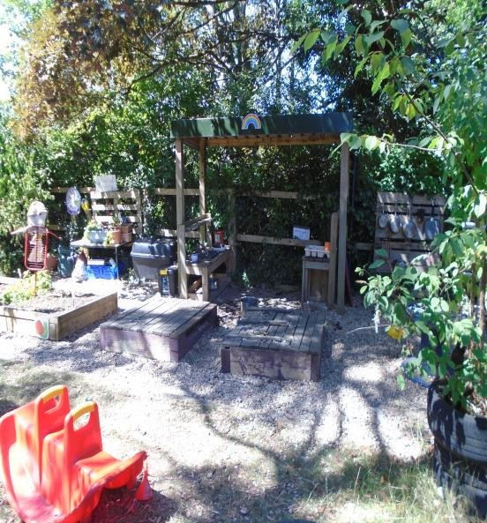
We are a term-time, sessional pre-school based in Thornbury, taking children from the surrounding community.

We currently occupy two classrooms within Manorbrook Primary School but will be soon moving to a brand new, purpose built setting in a new spot within the school grounds.

In addition to excellent indoor facilities we understand the importance of the outdoors for children and as such offer all year round access to a mature, natural garden.

Rainbow Teddies were excited to achieve an overall Ofsted inspection grade of ‘Good’ at the last inspection (September 2025). Our wonderful report can be found by using this link
https://files.ofsted.gov.uk/v1/file/50290430

We are a member of the Early Years Alliance and are registered with OFSTED.

We are registered with the local authority to receive free Funded Entitlement hours as well as the extended 30 hours available to working parents. We accept both Tax-Free childcare and Childcare Vouchers.

Rainbow Teddies Pre-school is a non-profit making charitable organisation run by a voluntary Management Committee. The members are elected during our Annual General Meeting which is held in the Autumn. The Management Committee have overall responsibility for Rainbow Teddies Pre-school with the Pre-school Manager (Marie) being in charge of the day-to-day running of the setting.

All families with children attending the pre-school are ‘members’ of the pre-school. We value working with parents/carers as partners in their children’s care and development. We provide various opportunities throughout the year, where parents and carers can become actively involved with the group. We hope that everyone will be able to support the pre-school eg serving on the Management Committee, helping in session or providing support at events which happen during the year. We firmly believe that all parents/carers have a variety of skills and strengths that they can bring to the pre-school and actively encourage their support and involvement.

The pre-school operates a waiting list and places are usually offered on a first come, first served basis depending on meeting our age requirements. Application forms for the waiting list are available from Rainbow Teddies Pre-school or details can be given to the Pre-school Manager in writing or by e-mail: rainbowteddiesprechool@gmail.com

Parents and children are welcome to visit at any time to meet with the staff and learn more about Rainbow Teddies Pre-school. An appointment is not always necessary but a phone call will ensure you visit at a convenient time for someone to speak with you.

Everyone involved with the pre-school on a regular basis is subject to DBS vetting.

Further information about the pre-school can be accessed via our website at: www.rainbowteddies.org.uk

LOCATION
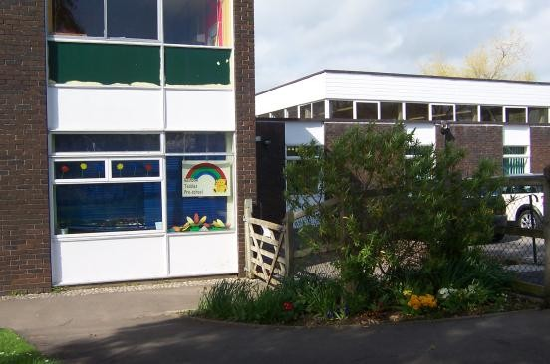
Rainbow Teddies Pre-school
Park Road
Thornbury
South Glos
BS35 1JW

Tel: 01454 867231
Email: rainbowteddiespreschool@gmail.com
Website: www.rainbowteddies.org.uk

All enquiries should be directed to the Pre-school Manager (Marie), on the above number or by emailing: rainbowteddiespreschool@gmail.com.

For safety reasons and as a courtesy to Manorbrook Primary School please do not park within the school gates.

INTRODUCING YOUR CHILD TO PRE-SCHOOL

Following the letter of acceptance parent/carers should feel free to bring their child to visit Rainbow Teddies Pre-school at any time and as many times as they like. However, a phone call would be appreciated to ensure the visit is mutually convenient.

An appointment can be made by contacting the Pre-school Manager (Marie) on 01454 867231 or via email: rainbowteddiespreschool@gmail.com. Settling-in sessions will allow parents and children to see how the sessions run and introduce them to the routine, staff and environment.

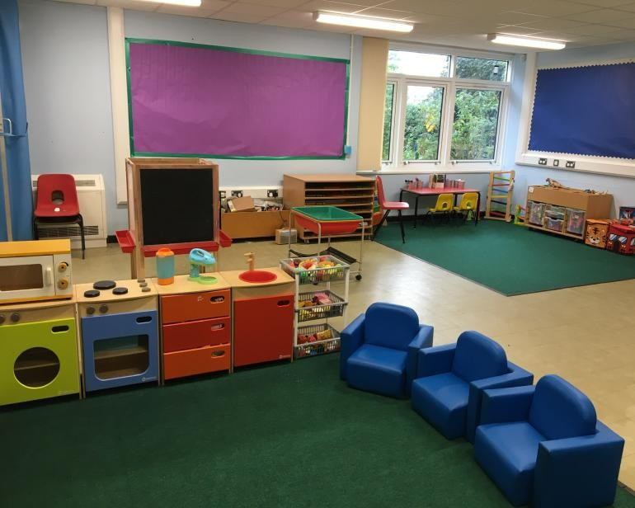
TERM DATES 2026/2027

AUTUMN 2026
Term 1:
Monday 7th Sept – Friday 23rd Oct
(South Glos- Tuesday 1st Sept to Friday 23rd Oct)
Term 2:
Monday 2nd Nov – Friday 18th Dec
(South Glos- same)

SPRING 2027
Term 3:
Monday 4th Jan – Friday 12th Feb
(South Glos- same)
Term 4:
Monday 22nd Feb – Thursday 25th Mar
(South Glos- same Friday 26th Mar Bank Holiday)

SUMMER 2027
Term 5:
Monday 12th Apr – Friday 28th May
(South Glos.: same)
Term 6:
Monday 7th Jun – Friday 16th Jul
(South Glos.: Monday 7th Jun to Wednesday 21st Jul)

These dates may be subject to change.

The setting will endeavour to give as much notice as possible if changes are made.

MESSAGE FROM THE MANAGEMENT COMMITTEE

Did you know that the Management Committee is mainly comprised of a group of volunteer parents/carers of children currently attending the setting?

The Management Committee oversee the running of the pre-school.

Did you know that the Pre-school cannot run without a Management Committee?

Members of the Management Committee are all elected by parents/carers at the pre-school's Annual General Meeting (AGM) which is held during Term 1.

We will be looking for new members at the next AGM!

We are responsible for helping to:
- ensure that all safeguarding requirements are met
- oversee the pre-school’s finances and make decisions about larger purchases
- employ the Manager of the pre-school
- ensure that the pre-school has and adheres to policies that help us to provide a high quality
service
- ensure that the pre-school works in partnership with the children's parents.

We also get involved in a whole variety of other activities, such as:
- fundraising
- applying for grants (where applicable)
- organising events for the children
- helping the staff resolve any complex problems
- making decisions on behalf of the pre-school, in collaboration with the Manager

Committee Meetings
We meet every couple of months, generally once a term (6 x per year).
There is a requirement that at least 5 people are present; so the more people there are on a committee, the better!

Would you like to be involved?
The more people we have on the committee, means less work for everyone involved!

We would welcome help from any parent/carer interested in becoming more involved with the pre-school. You can help on an ad-hoc basis, for example, to support a fundraising event, or on a more regular basis, by attending committee meetings and becoming involved in discussions and decision making!

Want to know more?
If you would like to know more about your Committee and how you could get involved, please contact the Pre-school Manager at the setting who will put you in contact with a member of the Committee.

OPENING TIMES AND PAYMENTS

Monday to Friday during term time only (please see Term Dates)

Rising School Group
(children who will begin Primary School the following Sept)

Short Session: 9.00am to 11.30am
Lunch Session: 9.00am to 12.45pm
Long Day Session: 9.00am to 3.00pm

Teddy Tot Group
(children from 2.5 years and 3 year olds)

12.30pm to 3.00pm

COSTS
Voluntary Administration Fee £25 (requested once place confirmed – see
welcome pack for full details)

Teddy Tot session (2.5 hours) £8.50 per hour (£21.25 per session if
funded hours not
applicable)

Rising School Excess Hours £6.50 per hour

Termly Consumable Fee* £0.80 per session (full day = 2 sessions)
*voluntary for children using funded hours

Funded Entitlement (FE)
The group is registered to receive payments for children’s funded entitlement hours - these are funded by the local authority. For full details and to check your eligibility for any of the schemes, please visit www.beststartinlife.gov.uk. Please see the information below regarding the different schemes currently available.

Universal Entitlement
All children in England aged 3&4 are able to claim up to 15 hours under Universal Entitlement. You are able to begin claiming these hours from the first ‘big’ term following your child’s 3rd birthday ie 1 Sept, 1 Jan or 1 Apr. Funding can be split across multiple settings and is paid for 38 weeks of the year. Some settings are able to stretch the funding to cover a full year but please check with your provider for more information if this is the case. Rainbow Teddies is open for 38 weeks of the year. Please see term dates above for full details. Please note, no code is required if you are simply using the Universal Element of funding.

Childcare for Families in England receiving some additional forms of Government Support
Up to 15 hours childcare could be available to families of children aged 9mths +, who are receiving additional Government support/benefits. Please follow the above Best Start in Life link to check eligibility and make an application. If approved, you will receive a code which needs to be given to the setting.

Extra Entitlement for Working Families
Up to 30 hours for children aged 9mths+
Please check eligibility using the Best Start in Life link above. If successful, you will be provided with a code which needs to be given to the setting. This code will need to be renewed throughout the year to remain valid. This is the responsibility of the parent/carer.
Parents will be expected to pay for any additional hours taken which are not covered by the FE scheme(s), at the rate of £6.50 per hour for Rising School group and £8.50 per hour for Teddy Tot group.

Code of Practice for Funded Entitlement
Where a child is away from pre-school for 5 days or more, we require either an email or completion of an Absence Form providing details/reason for the absence. Pre-printed ‘Absence Forms’ are available for your convenience; please ask any member of staff.

FEES PAYMENT POLICY

Rainbow Teddies Pre-school endeavours to operate a fees payment system that will be both fair and reasonable for all parties involved. On joining the pre-school it will be expected that all parents/carers will abide by the policies of the pre-school, including the payment of fees.

Maintaining a Fair Payment System
A £25 administration fee will be requested at the time of acceptance of the pre-school place. This is to cover costs such as name labels, peg/registration card photos, staff costs to be able to provide free settling-in sessions and general admin involved with new placements. This fee is not compulsory for children using Government Funded Hours but is very much appreciated to help cover the above-mentioned costs. If Government Funded Hours are not being used, this fee will be required.

At the beginning of the term a fees invoice will be presented to all those who are due to pay fees. The fees should be paid by the date indicated. Payment is preferred by BACS or voucher scheme however, other payment methods can be discussed with either the Financial Administrator or Pre-school Manager. The pre-school bank details will be found on the invoice. It will be the parents/carers’ responsibility to pay the fees by the due date. A £10 late payment fee will be issued for fees which are not paid in full by the end of term 2, 4 and 6, unless a pre-arranged repayment plan is in place.

Any difficulties with payments should be discussed with the Pre-school Manager, Finance Administrator, Chair or Treasurer of the Management Committee as soon as possible.
In special circumstances, at the Manager’s discretion, a flexible payment system can be negotiated. However, if fees are defaulted under this flexible payment system then the availability of the system will be withdrawn and the total fees will be due immediately.

If full payment of fees, regardless of payment system, is not cleared by the end of the term, the Committee may, reluctantly, have to consider the withdrawal of the child’s place. In this instance, the parents/carers will be notified by letter.

Where a flexible payment system is agreed i.e. a spread payment system and the child leaves the pre-school prior to the end of the academic year, the full amount of fees due for the sessions attended up to the date of leaving will be due. The parents/carers will be invoiced for the outstanding balance. The payment will be requested immediately.

NON PAYMENT OF Fees - The Finance Administrator will contact the parent/carer to discuss payment/repayment plan. If this does not succeed, the Manager will also engage with the parent/carer to discuss a repayment plan. If this does not conclude the matter, or if a repayment plan is not adhered to, the Committee will aim to recover the debt via the Small Claims Court, the Finance Administrator will set this up and the Chair will authorise.

There will be no refund of fees due to illness or holidays. However, a refund/reduction of fees for non-attendance due to long-term illness may be negotiated with the Committee.

We will require 4-week’s paid notice if a parent/carer wishes to reduce the number of sessions allocated to their child. This will also apply if a child is eligible for FE, where the pre-school will retain 4 weeks of payments as part of this period notice.

Childcare Vouchers
Where parents wish to use this method of payment, the pre-school will accept work place child care vouchers as full or part payment of fees.

Where the vouchers only cover part of the costs, then the parent will be expected to make up the difference in the payment of the balance.

If a parent feels that the vouchers will not be paid in time, then fees should be paid in the normal way to ensure that there are no arrears of payment.

Claiming Free Entitlement (FE)
Parents/carers of eligible children will need to complete a Parent Declaration Form which the pre-school will issue on behalf of the local authority, at the start of each ‘big’ term (autumn, spring and summer). We require these forms to be signed and returned to pre-school every term along with any requested documentation; they will be re-issued each term with a covering note attached for you to sign. The setting is unable to claim FE hours without all procedures being complete so therefore, failure to provide requested documentation within the correct timescales, will result in the parent/carer being liable for any session fees incurred.

Please see above for full details of all Funding Entitlement schemes available.
If Rainbow Teddies Pre-school is open less than the full entitlement the pre-school will only claim the sessions it is entitled to.

If you already use most or all of your hours at another setting, but would like your child to access more sessions at Rainbow Teddies, this could be possible (providing we have the space) if you qualify for any of the Extended Entitlement schemes, or are willing to pay for the ‘excess hours.’

You can split funding across multiple providers per day.

Any attendance over and above that covered by the funded hours scheme(s) will be invoiced accordingly: £6.50 per hour (Rising School group) and £8.50 per hour (Teddy Tot group).

Consumable Fees
At the start of each small term an invoice will be issued to all parents/carers to help cover the cost of children’s snacks. This cannot be paid using any of the funded hour schemes. Costs are as follows: 80p per session (a full day equates to 2 sessions). For children using funded hours, the fee is not compulsory but is very much appreciated. If you pay for your child’s session fees in their entirety, this fee will be required. If you opt to not pay the Consumable Fee, the Manager/Finance Administrator will speak to you to discuss possible alternatives such as providing a snack from home which complies with the setting’s Food and Nutrition Policy. Failure to pay the termly Snack Fee, will not adversely affect a child’s pre-school place.

THE AIMS OF RAINBOW TEDDIES PRE-SCHOOL

To provide a fully inclusive setting, welcoming all children.

To recognise the importance of the home life of the child and build on this foundation by working closely with parents and carers.

To provide a safe and stimulating environment where children can learn through play, allowing children to gain social skills, confidence and independence through interaction with other children and adults.

To provide a curriculum that aims to meet children’s needs by providing a base for development and learning, which works alongside activities which have been identified by the child’s ‘key person’ through observations and monitoring.

To be guided by the children; when the play is motivated by a child’s activity or interest.

To encourage a caring, sharing attitude between the children, giving rise to self-respect and respect for others.

To provide an environment which encourages independent learning and which creates a relaxed atmosphere, where the child
is able to develop at his or her own pace.

To provide the time and opportunity for a child to develop in all areas, through a wide range of experiences and activities that are organised and planned in an enjoyable, secure and caring atmosphere.

To provide children with activities and experiences which foster an awareness of their environment and the wider world.

To prepare the children for the transition from pre-school to full time school.

We aim to provide opportunity for all children to have access to good quality education, based on a broad based curriculum delivered by well-qualified staff.

Overall, our aim is for the children to have fun and to learn through their play!

FOOD AND DRINK

The pre-school provides a generous variety of nutritious snacks and a daily drink of milk and/or water during snack times. Water is also always available throughout the day.

Snacks will vary and will sometimes coincide with a current theme or topic being explored.

We request that lunch boxes reflect a healthy balance of food groups (no sweets please – the children will not be allowed to consume these whilst at the setting) and that the amount of food provided is suitable for small appetites!

Please ensure that we are notified of any allergies and/or any other dietary needs.

*Please note we are a nut free setting so please do not send products which contain nuts ie muesli type bars, chocolate spread, bakewell tarts, macarons etc

CLOTHING

Aprons are provided when play is messy or for cooking but paint stains etc. do occur. It is advisable that children are not dressed in anything that will cause upset if it is stained. All clothing that might be removed should be named, ie coats, jumpers, cardigans. We advise that clothing should be ‘easy to manage’ such that children are more able to successfully manage their own personal hygiene.

Rainbow Teddies sweatshirts and polo tops are available for sale - please speak to the Manager.

COMMUNICABLE DISEASES AND EXCLUSION TIMES
Please ring the setting to report if your child is ill giving details of the illness in line with our Absence Policy.

If a child or adult has a ‘non-excludable’ illness (as defined by the local Health Protection Agency- HPA) the pre-school reserves the right to exclude them for a short time, if it is deemed appropriate in order to help reduce the possibility of widely spreading the infection to others, for example in the case of severe *conjunctivitis- fees will still be payable in such instances, as applicable.
Please seek medical advice from your own doctor or further information can be accessed via the NHS or UK Health Security Agency websites. Should your child be sick with a communicable disease, the table below shows the recommended exclusion times from pre-school:

Disease Exclusion Period
Chickenpox | Until blisters are crusted over, or skin has healed- usually 5 days.  Pregnant contacts should consult with G.P.
Cold and Flu like illness | Until they no longer have a high temperature and feel well enough to attend.
*Conjunctivitis  See note at top | Usually no exclusion; unless deemed necessary to prevent the spread of infection at pre-school
Sickness and/or Diarrhoea | For 48 hours after the last episode.
German Measles/Rubella | 6 days from onset of rash.  Pregnant contacts should consult with G.P.
Hand, foot and mouth | No exclusion but child needs to be well without the need of medicines
Head lice | No exclusion, but treatment required and contact tracing essential.
Impetigo | For 48 hours after antibiotic treatment and once lesions have crusted over.
Measles | For 4 days after onset of rash.
Mumps | For 5 days from onset of swollen glands.
- Ringworm of Feet (Athlete’s Foot)  - Ringworm of the body/scalp | - No exclusion, but treatment advisable  - Exclusion- until appropriate treatment has  commenced
Rotavirus | For 48 hours from last episode of diarrhoea or vomiting.
Scabies | Until 1st application of treatment has been completed- close contacts also require treatment
Scarlet fever | 24 hours after commencing antibiotic treatment
Threadworm | No exclusion- but treatment required
Whooping cough | 48 hours after commencement of anit-biotics
Fifth Disease (Slapped Cheek) | No exclusion- but please let the setting know pregnant contacts: seek GP advice

TEDDY TOTS

These sessions run Monday to Friday afternoons from 12.30pm until 3.00pm. From 1pm, these sessions run in tandem with the afternoon Rising School group (ie a mixed age group) and then separate again into two groups from 2.40pm.

Where spaces allow, children will be offered a place from 2½ years of age. Whilst children are under three years of age, ratios will be 1 adult to 5 children (generally 1 adult to 4 children). From 3 years of age the ratio rises to 1 adult to 8 children.

As the children on these sessions are so young and develop at different rates we have outlined some guidelines which will help parents settle their children into the pre-school routine.

We recommend that parents/carers visit us beforehand with their child, as it is a good opportunity for them to familiarise themselves with the pre-school environment. Once your child officially starts with us, we will work with you, with regards to helping them to settle in; it may be that you prefer to stay with them for a while, or you may want to hand them over to a member of staff and leave quickly! Tears are very normal in the beginning (for children and parents!) and we are very sensitive to this; we will telephone you to reassure you that your child has settled if you would like us to do so.

If there is a prolonged and unhappy settling in period, the key person will discuss the situation with the parent/carer and will suggest strategies for settling the child or may even suggest that the child’s entry to pre-school is delayed for a few weeks. There is no pressure for the child to be left until the parent and child are both happy.

We would advise parent/carers to be prompt for collection of their child at the end of the afternoon, so that he/she leaves the session feeling confident and happy.

If a child is not fully toilet trained, then parents should discuss this with the child’s key person, to ensure that the child can be appropriately supported (see Toileting Policy).
From the following September, all children attending the Teddy Tot Sessions will be offered a place in our Rising School Group.

TEDDY TOT SESSION ROUTINE

Although staff will keep to the start and end of session times, other timings are approximate and may be influenced by other activities etc occurring during the sessions.

12.30pm - children and parents are welcomed at the door
For the first 30 minutes, children remain in this room solely with their peer group, allowing them to settle, in a quieter, less busy environment.
The Session Leader ensures that a register is kept of all staff and children (and any parents/carers) in attendance.
During this first 30 minutes, the children will be invited to join a group activity such as a story, song or what’s in the bag type activity, targeted keyperson activity or free play.
1pm – outside is opened allowing for free flow of play and both groups combine.
During the remainder of the session, some activities will be adult led whilst other activities allow the children to explore and use resources in their own way.
2.00pm - Children are invited to have some food and milk or water (‘snack time’).
2.30pm – Children are encouraged and assisted to help tidy away toys etc. The two groups then separate for age appropriate end of day activities such as singing and/or stories.
2.40pm- End of session activity/group time.
3.00pm – Children will be released one by one to an authorised adult

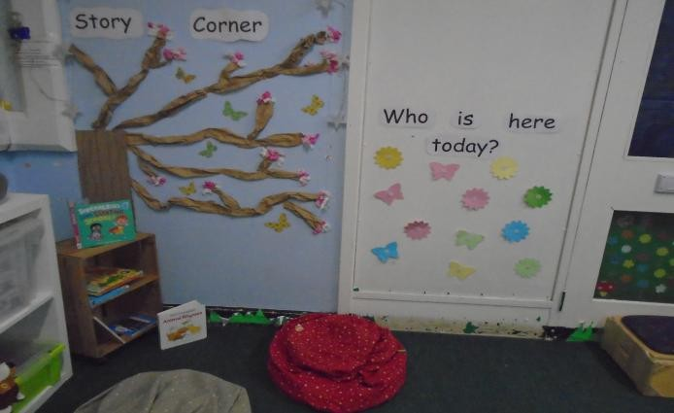

RISING SCHOOL

At some point before Term 1 starts, children due to start in September and who are ‘new’ to Rainbow Teddies, will be invited in with their parent(s) to enable them to meet the staff team and to allow them to experience and explore the pre-school environment.

We provide the children with a variety of opportunities and experiences, to build on skills in all areas of learning. We support children in building confidence, independence and resilience, so that they are better prepared for the next steps in their school journey.

We explore various termly themes and organise trips to local places of interest, such as the school woodland or local streamside and visits to places such as Cattle Country.

During the Rising School year we link up with Manorbrook Primary School to aid transition. All children get to experience using the ‘big’ school hall for physical activities/performances.

During the summer term, Reception teachers from our local schools also visit the setting to introduce themselves to their September starters and meet with the children’s keyperson, to discuss transition.

RISING SCHOOL ROUTINE

Although staff will keep to the start and end of session times, other timings are approximate and may be influenced by other activities etc occurring during the sessions.

9.00am - Children and parents/carers are welcomed.
9.10am – Welcome carpet time. The register is taken for the children. The Helper of the Day is chosen. The weather/date board is completed and the registration cards are counted.
Sound of the week and Makaton sign of the week are discussed and any show and tell items shared. Children may also wish to share exciting news with the staff and their peers. This part of the session generally lasts approximately 10 mins.
9.30am – Snack is opened. A sociable time spent in keygroups with the relevant keyperson. This is then followed by supervised toothbrushing (details will be provided in September).
The children are then able to explore a mixture of adult led and free play activities, following our published curriculum, making use of both the indoor and outdoor spaces. Our outside space is opened at approximately 10am offering free flow play. Small groups of children will be involved in keyperson activities with their adult and any necessary SEND strategies will be completed (if not already done earlier in the session).
Short Session ends 11.30am. Parents/carers collect children from gate.
11.40am – Outside area is closed and children are encouraged and assisted to tidy away toys etc.
11.50am - Children gather on the carpet ready for washing hands.
12noon – Children eat their packed lunches followed by a story, songtime, music, yoga activity
12.45pm – Children on Lunch Sessions are collected and the outdoor space is re-opened for free flow play.
A variety of adult supported activities and spontaneous play, both in/outside, will take up the rest of the afternoon. A small group of children will be invited to an adult led learning activity based on our curriculum.
2pm - A snack and drink of water/milk will be offered.
3 pm - Children will be released, one at a time to an authorised adult.

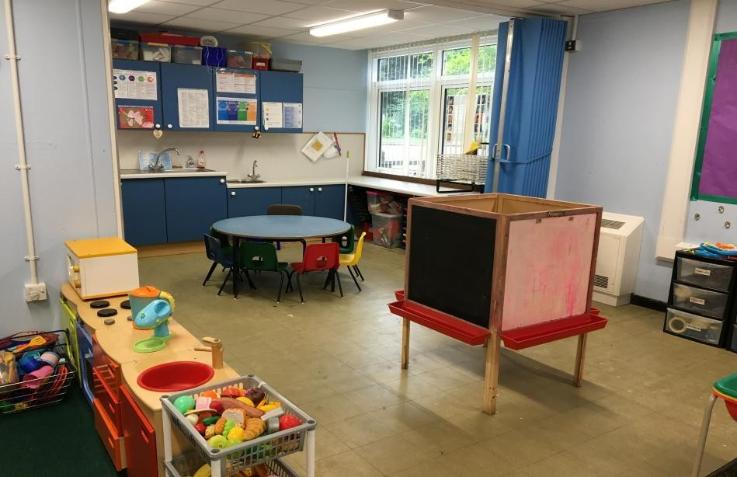

CHILDREN’S DEVELOPMENT & LEARNING

The provision for children's development and learning is guided by The Early Years Foundation Stage (EYFS/DfE 2025). Our provision reflects the four guiding themes and principles of the Early Years Foundation Stage. Please visit our website to view both our Teddy Tot Group and Rising School Group curriculum.

A Unique Child
Every child is a unique child who is constantly learning and can be resilient, capable, confident and self assured.
Positive Relationships
Children learn to be strong and independent through positive relationships.
Enabling Environments
Children learn and develop well in enabling environments, in which their experiences respond to their individual needs and there is a strong partnership between practitioners, parents and carers.
Learning and Development
Children develop and learn in different ways. The framework covers the education and care of all children in early years provision, including children with special educational needs and disabilities.

How we provide for development and learning
Children start to learn about the world around them from the moment they are born. The care and education offered by our setting helps children to continue to do this by providing all of the children with interesting activities that are appropriate for their age and stage of development.

The areas of Development and Learning comprise:
Prime Areas
- Communication and Language (CL)
- Personal, Social and Emotional Development (PSED)
- Physical Development (PD)
Specific Areas
- Literacy (L)
- Mathematics (M)
- Understanding the World (UW)
- Expressive Arts and Design (EAD)

For each area, the level of progress children should be expected to have attained by the end of the Early Years Foundation Stage is defined by the Early Learning Goals. These goals state what it is expected that children will know and be able to do by the end of the Reception year of their education.
The ‘Birth to 5 Matters’ guidance sets out the likely stages of progress a child makes along their learning journey towards the Early Learning Goals. Our setting has regard to these matters when we assess children and plan for their learning.
Personal, social and emotional development:
Making relationships; self-confidence and self- awareness; managing feelings and behaviour.
Skills will be developed to encourage children to be independent learners, play cooperatively, learn to share and take turns. Children will be encouraged to choose their own resources and activities.
Physical development:
Moving and handling; health and self-care.
The variety of resources, equipment and opportunities available will help children to develop both large and small motor skills and hand/eye coordination.
Communication and language:
Listening and attention; understanding; speaking.
These skills will be developed with the enjoyment of books, stories, songs and rhymes. Children will be encouraged to listen and will be given time to develop and use language skills; having ‘a voice’ in group situations and as individuals.

Literacy:
Reading and writing.
Along with sharing books, stories, rhymes and songs, children will experience lots of activities which will help to develop pre-writing and emergent writing skills
Mathematics:
Numbers; shape space and measure.
Skills such as number awareness, using and understanding mathematical language and exploring shapes, space and measures will all be developed in a play environment.
Understanding the world:
People and communities; the world; technology
Children will be encouraged to explore: objects, materials and living things. They will use some ICT and learn about similarities and differences between themselves and others.
Expressive arts and design:
Exploring and using media and materials; being imaginative.
Including role play, music and dancing. Children will explore a variety of materials, tools and techniques and experiment with colour, texture, form and function.

Learning through play
Play helps young children to learn and develop through doing and talking, which research has shown to be the means by which young children learn to think. Our setting uses the Early Years Foundation Stage Birth to 5 Matters guidance to plan and provide a range of play activities which help children to make progress in each of the areas of learning and development. In some of these activities children decide how they will use the activity and, in others, an adult takes the lead in supporting the children to engage with the activity and maybe try something new.

Characteristics of Effective Learning
We understand that all children engage with other people and their environment through the ‘characteristics of effective learning’:
- playing and exploring - engagement
- active learning - motivation
- creating and thinking critically - thinking
The group’s curriculum is guided by the Early Years Foundation Stage (EYFS) as described above.
Children’s individual needs will be met via a well balanced and varied curriculum. The activities will be guided by a core curriculum and the individual needs of the children. (See Monitoring and Key working)
TAKING THE CURRICULUM OUTSIDE

Rainbow Teddies Pre-school believes that children should have access to outdoor play all year round; the outdoor area will be used as an integral part of the learning environment.

Please ensure that appropriate outdoor clothing is always sent in with your child, as they will be outside in all weathers! Please make sure this is named.

MONITORING AND KEYWORKING

Rainbow Teddies Pre-school aims to provide for the needs of the individual child.

We operate a ‘keyperson’ system whereby all children are allocated a qualified member of staff who will be responsible for liaising with parents, monitoring the progress of a group of children and coordinating each child’s ‘Learning Journey’ records.

We believe that parents/carers are the most important educators of their children and only by working together can we meet children’s individual needs.

Our Open Door Policy means that parents/carers can contact the pre-school at anytime with any concerns or worries they may have.

Our Confidentiality Policy means that all information about a child or family will be treated in the strictest confidence.

Key people will be available to talk about any queries or problems that parents would like to discuss regarding their child. This may require an appointment; parent/carers are advised to contact their child’s key person direct.

From entry to the Teddy Tots sessions, the key person will monitor how a child is settling and will be the main point of contact for parents/carers during those first tentative weeks. After a few weeks, parents will be invited to meet with their child’s key person to discuss how he/she is settling into pre-school life and to discuss the statutory 2 Year Progress Check.

2 Year Progress Check:
This is statutory requirement of the EYFS. When a child is aged between 24-36 months we have to provide parents/carers with a short, written summary about their child’s development in the three ‘prime’ learning and development areas of the EYFS: Personal, Social and Emotional Development; Physical Development; and Communication and Language development. The keyperson will discuss this with parents/carers and agree when would be the most appropriate time to undertake the written summary or to confirm that this will be undertaken at another setting; should a child spend more time during the week at another early years setting.

Throughout the child’s time at pre-school, his/her needs will be catered for by the keyperson using their knowledge of the individual children in their group to inform the educational programme/curriculum planning. The keyperson will carefully observe the children to gauge their interests, style of learning and overall development.
Rainbow Teddies Pre-school wants to work closely with parents and carers. At various times, throughout the year, the keyperson will invite parents/carers in, to discuss their child’s development and progress.

During the last Rising School meeting, the key person will discuss the child’s transition to school with parents/carers and decide what areas (if any) need special attention during the summer term.

The keyperson will be happy to talk over any matters that may arise between meetings.
More information about the EYFS and the progress check at age two, can be found at: www.foundationyears.org.uk and www.education.gov.uk

SPECIAL EDUCATIONAL NEEDS & DISABILITY (SEND)

The group operates under the guidelines of the DfE ‘Special Educational Needs and Disability (SEND) Code of Practice (Jan 2015). If parents/carers or staff have any concerns regarding any aspect of a child’s development, the issue will be discussed and parents and staff will work together to set up strategies to help the child. If necessary, the help of outside agencies can be called upon.

Our Special Educational Needs & Disability Coordinator (SENDCo) is Marie Collins (see also our Special Educational Needs & Disability Policy) and she is supported by Nichola Milton our Special Educational Needs & Disability Assistant.

POLICIES AND PROCEDURES

These are just a few references to our group’s policies and procedures. We encourage all parent/carers to read the full versions; they can be found in the cloakroom area at Rainbow Teddies Pre-school and on our website: www.rainbowteddies.org.uk

Equal Opportunities
The pre-school operates an ‘equal opportunities policy’ which means that all children are welcome regardless of their religion, race or gender or if they have any disabilities.
If a child has already identified special needs - whether physical or emotional, permanent or temporary – parent/carers are asked to discuss them with their child’s key person to enable us to provide the best and most appropriate support (see: Equality of Opportunity and Inclusion Policy and Special Educational Needs & Disability Policy)

Health and Safety
Staff members have a relevant paediatric first aid certificate. All accidents are recorded and parent/carers will be informed and asked to sign the record. In cases of sickness or more serious accidents we will refer to the contact list in the child’s Child Information Booklet (CIB) and/or make contact with emergency services as necessary.

Children or adults who have suffered sickness and/or diarrhoea are asked to stay away from the pre-school for 48 hours from the last episode.
Fire Drills and Emergency Evacuation practice will take place each term (see: Health and Safety Policy and Fire Drill and Emergency Evacuation Policy).

Open Door Policy
Parent/carers should feel free to discuss any comments or problems that they may have with the Pre-school Manager or Chair of the Management Committee. We are always striving to improve our policies and practices but are not able to do this without feedback from our users.
Please approach your child’s keyperson to discuss your child’s progress or any concerns you may have (see Open Door Policy)

Non-Collection of child
In the event of a child not being collected, contact will be sought with persons nominated as Emergency Contacts in the child’s ‘Child Information Booklet’ (CIB).
Failure to make contact will result in the session leader informing the emergency duty staff at social services (see Emergency Procedures Policy)

Safeguarding and Child Protection
We intend to create within Rainbow Teddies Pre-school, an environment in which children will be safe from abuse and in which any suspicion of abuse will be promptly and appropriately responded to. We work with statutory agencies and in accordance with the procedures as defined in ‘What to do if you’re worried a child is being abused’ (HMG 2015) and where appropriate we refer to ‘Working Together to Safeguard Children’ (HMG 2026). Where necessary, we seek advice/guidance from ‘South Gloucestershire Children’s Partnership’ (see Safeguarding and Child Protection Policy)

The designated ‘Safeguarding Lead’: Emily Greenslade
The designated ‘Deputy Safeguarding Officer’: Marie Collins

Behaviour Management
Smacking is not permitted in the pre-school. If a child is persistently disruptive then he or she may be taken to one side to have a chat with a member of staff. The member of staff will talk about the behaviour and explain why it was not acceptable. They will then suggest a better way that the child can deal with his/her feelings. If a child’s behaviour is giving cause for concern this will be monitored and discussed with the parent/carer (see Behaviour Management Policy)

COMPLAINTS

We believe children and parents/carers are entitled to expect courtesy and prompt, careful attention to their needs and wishes. Our intention is to work in partnership with parents/carers and the community generally and we welcome suggestions on how to improve our group at any time.

We believe that most complaints are made constructively and can be sorted out at an early stage. We also believe that it is in the best interests of Rainbow Teddies Pre-school and parents/carers that complaints should be taken seriously and dealt with fairly and in a way that respects confidentiality. We anticipate that most concerns will be resolved quickly by an informal verbal approach to a member of staff and/or the Pre-school Manager.

If the Manager has good reason to believe that the situation has child protection implications, then procedures will be followed in line with our Safeguarding and Child Protection Policy. If any party involved in the complaint has good reason to believe that a criminal offence has been committed, then they will contact the police.

Details of our Complaints Procedure are displayed in the cloakroom and a full copy of our Complaints Procedure is available upon request.

STAFFING
(See Safer Recruiting Policy)

All staff employed by the setting, or any volunteer attending the setting on a regular basis, will be vetted and undertake a Disclosure and Barring Service (DBS) check (previously known as a ‘CRB Enhanced Disclosure’).

Only people who have been suitably checked will have unsupervised access to children.

Each session will have a Session Leader qualified to at least Level 3 and a minimum of 50% of the remaining staff will be qualified. Staff are Paediatric First Aid trained.

Rainbow Teddies Pre-school facilitates funding and access to training for all members of staff. All members of staff are encouraged to attend courses to gain relevant qualifications, to acquire new skills and to update current methods and practices. Some of this training may take place within the setting.

Funding is provided for staff to update their first aid certificates.

The setting Manager and SENDCo’s update their training regularly to ensure that current practices are employed within the setting.

RATIOS

Rainbow Teddies provides very good adult to child ratios to ensure the safety of the children in its care. The ratio is at least one adult to five children for the under threes (more often 1:4) and one adult to eight children for the over threes.

During the course of the sessions, attention will be paid to the deployment of staff to maintain good ratios and supervision of all activities that children may be involved in.

For outings beyond the school perimeter we will have a ratio of 1 adult to 2 children.

Please note that complete copies of all policies & procedures can be found in the cloakroom area at Rainbow Teddies Pre-school and on our website: rainbowteddies.org.uk

STAFF POSITIONS AND QUALIFICATIONS
Name | Job Role/Title | Qualification
Marie Collins | Pre-school Manager  SENDCo | NVQ Level 3 in Children’s Care, Learning and Development.  SENDCo Level 3
Emily Greenslade | Deputy  Designated Safeguarding Lead  Curriculum Coordinator  Session Leader | Qualified Teacher with Early Years Professional Status
Nichola Milton | Curriculum Coordinator  Session Leader  Assistant SENDCo | Level 3 BTEC National Diploma in  Childhood Studies (Nursery Nursing)
Angharad Renno | Qualified Assistant | NVQ 3 Child Care and Education
Lisa Hayward | Qualified Assistant | BTEC Level 3 Early Years
Olivia Maunder | Qualified Assistant | Level 3 BTEC National Diploma in  Childhood Studies (Nursery Nursing)
Kazz Toctan | Qualified Assistant | City & Guilds NVQ Level 3 Children’s Care, Learning & Development
Annie Tufnell | General Assistant | NVQ 3 Child Care and Education
Joanne Gallagher | General Assistant | No child care qualifications
Erin Stubs | General Assistant  Level 3 Trainee | Working towards Level 3 Early Years Education
Alice Goodman | General Assistant | Working towards Level 3 Early Years Education
Pre-school Manager: Has overall responsibility for the day to day running of the group. Ensuring that there is adequate staffing and supervision and that the setting provides a good quality educational programme; which meets all children's needs and is the main Health & Safety and Deputy Safeguarding Officer.
Curriculum Co-ordinators: Coordinates information from Keypeople to ensure that all children’s needs are met by planning & directing the group’s educational programme/curriculum activities.
Session Leader: Has responsibility for the children and staff on each session. Ensures that all children are safe and cared for by providing good supervision and a high quality of teaching. Directs activities and opportunities.
Deputy Manager: Supports the Manager in her role. ‘Steps up’ when delegated by Manager. Is the Designated Safeguarding Lead.
Qualified Assistant: Supports the Manager/Session Leaders. Ensures the children remain safe, receive quality provisions and inclusive opportunities to learn and have fun.
General Assistant: Supports the Manager/Session Leaders and Qualified Assistants. Ensures the children remain safe, receive quality provisions and inclusive opportunities to learn and have fun.
www.ofsted.gov.uk – publishes OFSTED reports
Children and families | BETA - South Gloucestershire Council (southglos.gov.uk) - Access to all early years information and access to Children and Young People Information Services www.education.gov.uk – further information about education
www.hm-treasury.gov.uk – details about the government’s 10 Year Child Care Strategy
early years alliance | (eyalliance.org.uk) - represents and supports 15,000 community preschools



Rainbow Teddies Pre-school
Manorbrook Primary School
Park Road
Thornbury
South Gloucestershire
BS35 1JW
Registered Charity No. 1022411

www.rainbowteddies.org.uk

